📘 Pandemic Patterns: Unveiling COVID-19 Dynamics in India Through Excel Dashboard Analytics

Cover Page
Project Title: Pandemic Patterns: Unveiling COVID-19 Dynamics in India Through Excel Dashboard Analytics
Name: Tauseef Alam
Batch: DS ProX56
Course: Excel Analytics
Dataset Name:
- covid_19_india.csv
- covid_vaccine_statewise.csv
- StatewiseTestingDetails.csv

Section 1: Project Overview & Objectives

Project Overview
The COVID-19 pandemic significantly impacted India, presenting complex challenges across healthcare, governance, and public awareness. Large volumes of data were generated daily, including confirmed cases, recoveries, deaths, testing figures, and vaccination progress across states and union territories.
This project focuses on transforming raw COVID-19 datasets into meaningful insights using SQL for data processing and Excel for analysis and dashboard visualization. The aim is to provide a clear understanding of pandemic trends and state-wise impacts through interactive analytics.

Project Objectives
- To clean and transform raw COVID-19 data using SQL (ETL process)
- To analyze case trends, testing efficiency, and vaccination progress using Excel
- To build an interactive Excel dashboard for visual storytelling
- To identify key insights and actionable recommendations based on data
- To enhance analytical, visualization, and reporting skills

Section 2: ETL Phase (SQL)

ETL Overview
The ETL (Extract, Transform, Load) phase was performed using SQL in the Google Colab / PostgreSQL environment. The raw datasets were imported, cleaned, standardized, and aggregated before exporting them for Excel analysis.

Key ETL Tasks Performed
- Converted date columns into standard date formats
- Standardized state names across datasets
- Calculated:
  - Daily new cases using LAG()
  - Case Fatality Rate (CFR)
  - Positive Rate
- Aggregated data state-wise and date-wise
- Merged case, testing, and vaccination datasets

SQL Environment & Queries
🔗 Colab / SQL Notebook Link:
https://colab.research.google.com/drive/1ULCrBcfC0AycGYzzp2Eoopn05HAcrMNH?usp=sharing
📌 The notebook includes:
- Data loading
- Transformation queries
- Final tables exported for Excel

Section 3: Excel Analysis

Excel Analysis Overview
After completing the ETL process, the transformed datasets were imported into Excel for detailed analysis and dashboard creation.

Excel File
🔗 Excel File Link:
Covid_Summary_Final.xlsx

Key Excel Analyses Performed
- Daily and cumulative COVID-19 cases
- State-wise case proportion
- Testing analysis and positive rate calculation
- Vaccination progress (first dose, second dose)
- Risk assessment (High / Medium / Low)
- Month-wise and weekday trend analysis
- Time series forecasting using FORECAST.ETS
- Correlation analysis between testing and positive cases

Excel Dashboard
The Excel dashboard integrates all major insights into a single interactive view using:
- Line charts for trends
- Bar charts for state-wise comparison
- Cluster bar charts
📸 Dashboard Screenshots:
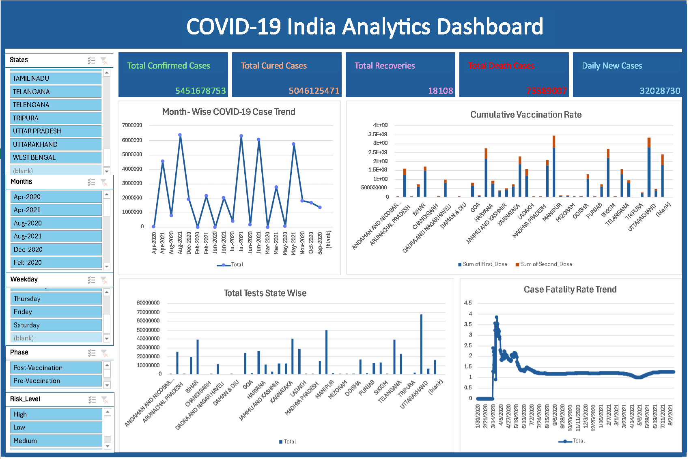
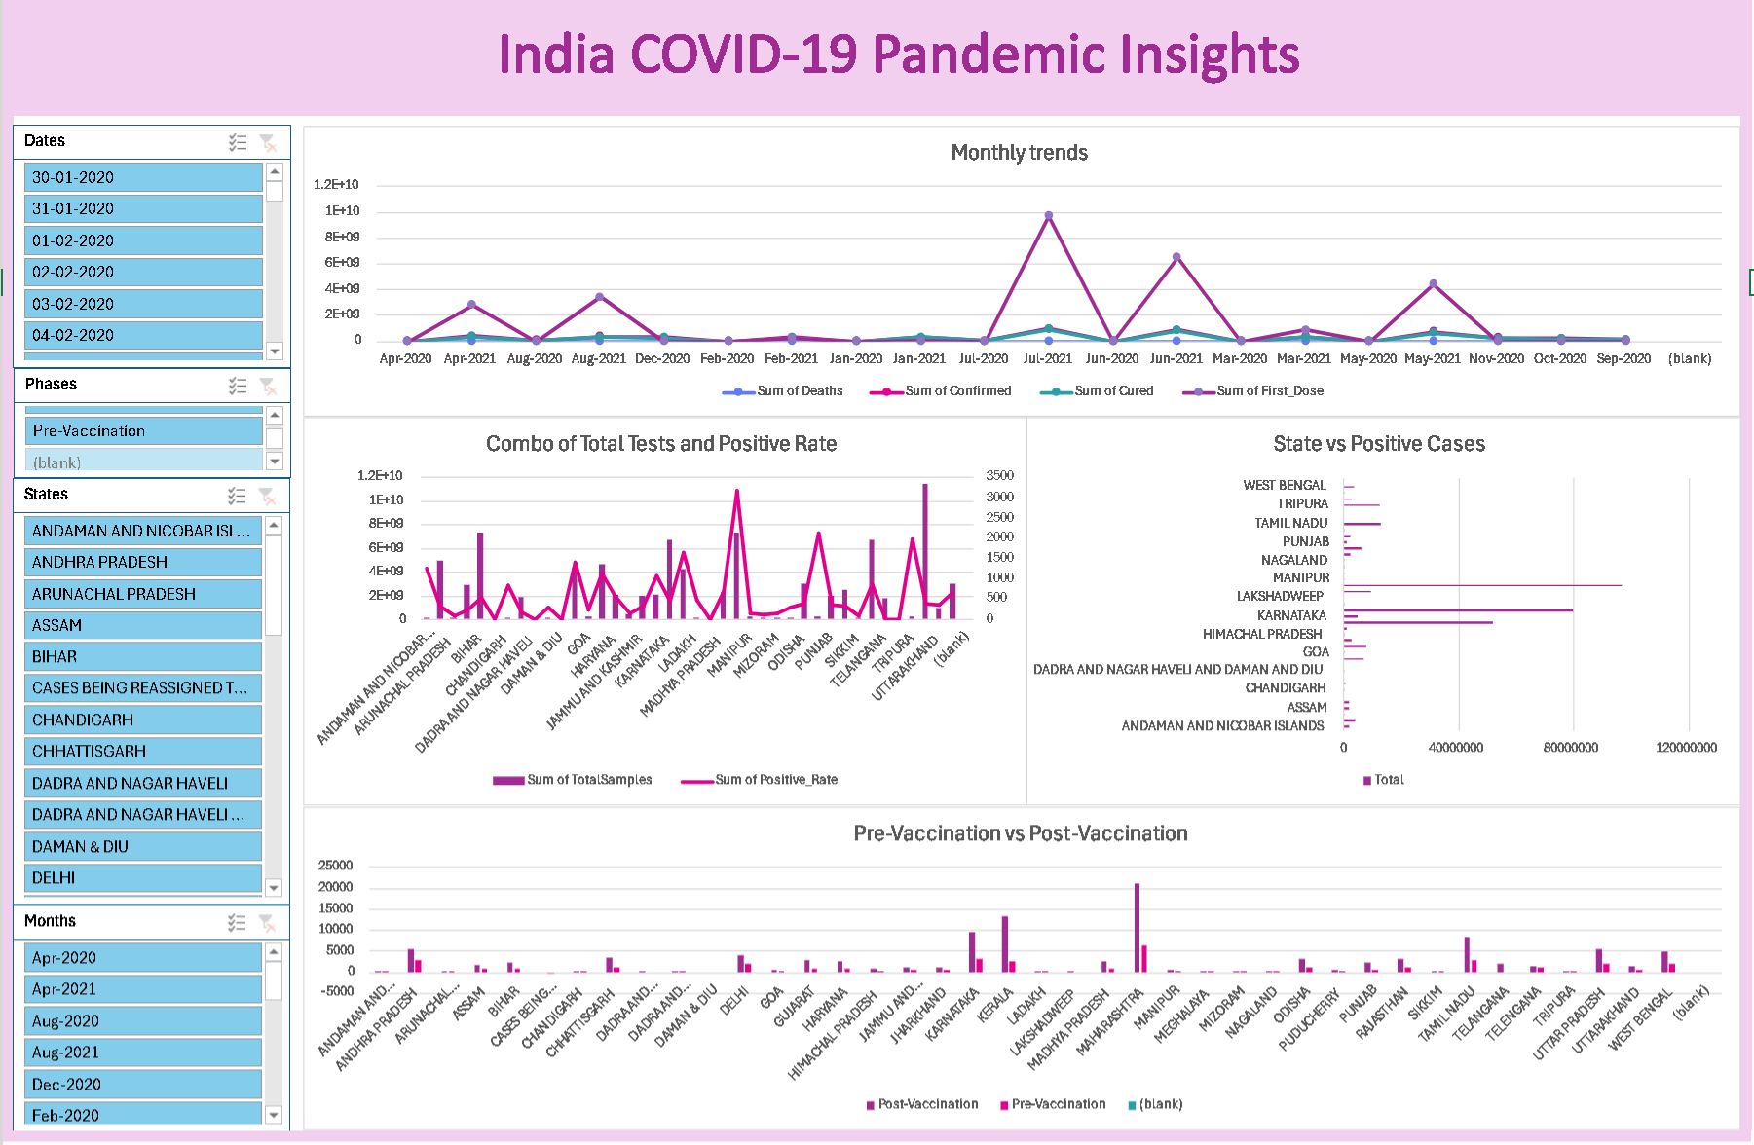

Section 4: Insights & Observations

Key Insights
- Uneven State Impact
States like Maharashtra, Kerala, and Karnataka showed consistently higher case loads compared to others.
- Vaccination Reduced Infection Severity
Post-vaccination periods showed a decline in average daily cases and fatality rates.
- Testing and Detection Correlation
States with higher testing volumes detected more positive cases, indicating effective surveillance.
- Positive Rate Variability
Some states showed high positive rates despite moderate testing, highlighting possible under-testing.
- Risk Concentration
High-risk states were clustered during peak pandemic waves but reduced over time with vaccination rollout.

Recommended Actions
- Increase testing in states with high positive rates
- Strengthen vaccination drives in low-coverage regions
- Use early trend detection for proactive healthcare planning
- Maintain robust data monitoring systems for future outbreaks

Section 5: Reflection

Challenges Faced
- Handling missing and inconsistent data across datasets
- Aligning dates and state names during dataset merging
- Managing large datasets in Excel efficiently
- Designing an interactive yet clean dashboard layout

Learning Outcomes
- Gained hands-on experience with SQL-based ETL processes
- Improved Excel skills including PivotTables, charts, slicers, and forecasting
- Learned how to convert raw data into actionable insights
- Developed a professional analytics dashboard
- Enhanced data storytelling and presentation skills

Conclusion
This project successfully demonstrates how data analytics and visualization can be used to understand large-scale public health events like the COVID-19 pandemic. By integrating SQL, Excel, and dashboard analytics, the project provides a comprehensive view of India’s pandemic journey and highlights the importance of data-driven decision-making.
Thank You !!

